Rename the file to this format: M6-Lab02-yourname.docx or pdf
Class & Module | SAH  Lab02: Building Supervised Learning Models/ Assignment2
Name | Goh Rui Kun
IC No. [S****123X] | S****836J
Date & Time | 19th Feb 2021 8pm

Create screenshot following the instruction below:
Step 1 of 4
- Following lab instruction, Upload the CSV (flights.csv) either using Azure Storage Explorer or Azure portal to Azure storage BLOB container in the folder named “data”
- then upload the python notebook: Python Classification.ipynb
- complete to run the steps in the jupyter notebook

create - paste the screenshot on the result of Test Model showing first 10 rows of the result
*** place here the screenshot of your data folder ***


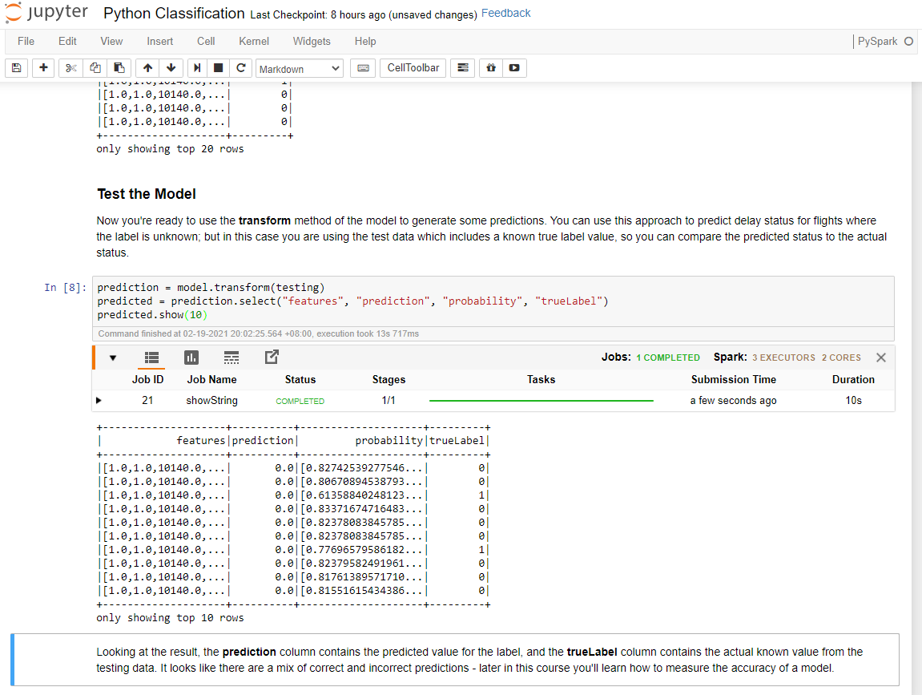

Step 2 of 4
- Following lab instruction, Upload the CSV (flights.csv) either using Azure Storage Explorer or Azure portal to Azure storage BLOB container in the folder named “data”
- then upload the python notebook: Python Regression.ipynb
- complete to run the steps in the jupyter notebook

create - paste the screenshot on the result of Test Model showing first 10 rows of the result
*** place here the screenshot of your data folder ***

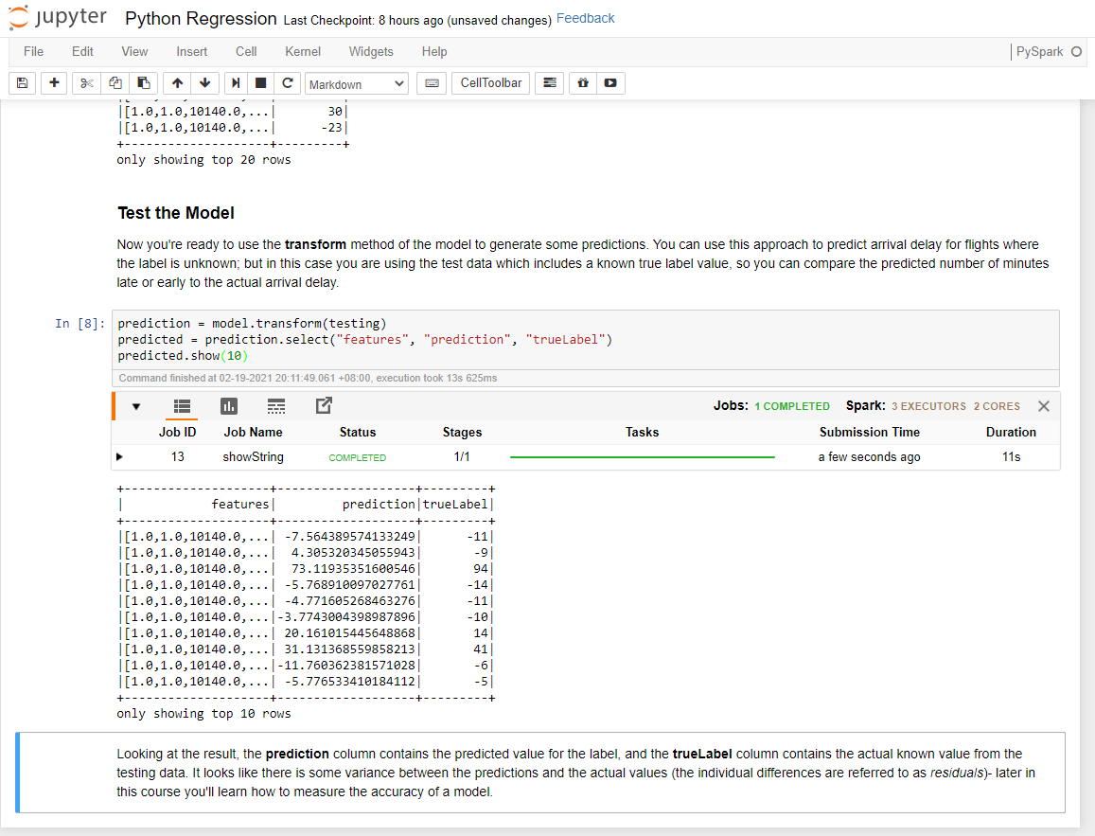

Step 3 of 4
- Following lab instruction, Upload the CSV (flights.csv) either using Azure Storage Explorer or Azure portal to Azure storage BLOB container in the folder named “data”
- then upload the python notebook: Python Pipeline.ipynb
- complete to run the steps in the jupyter notebook

create - paste the screenshot on the result of Test Pipeline Model showing first 10 rows of the result
*** place here the screenshot of your data folder ***
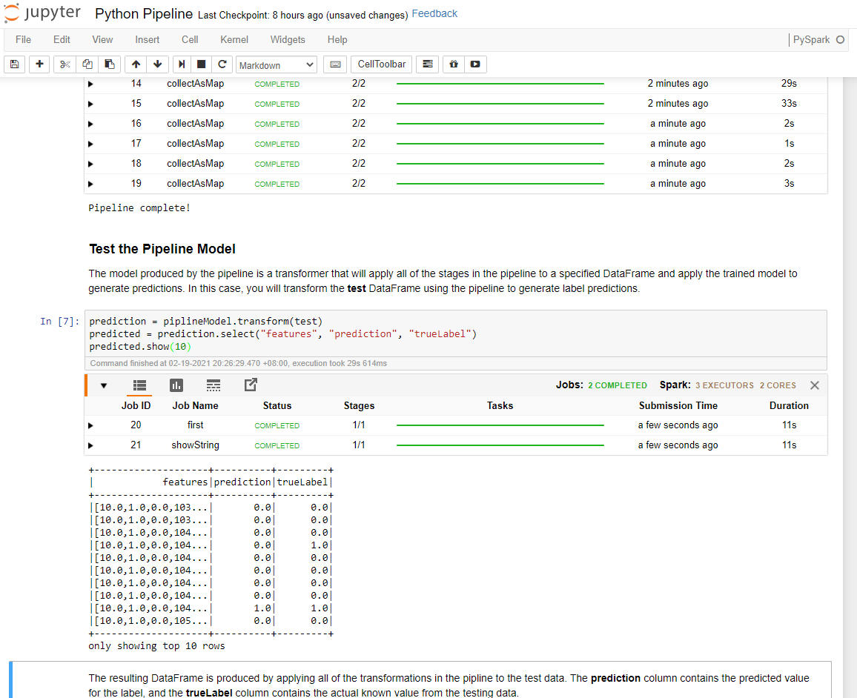

Step 4 of 4
- Following lab instruction, Upload the CSV (tweets.csv) either using Azure Storage Explorer or Azure portal to Azure storage BLOB container in the folder named “data”
- then upload the python notebook: Python Text Analysis.ipynb
- complete to run the steps in the jupyter notebook

create - paste the screenshot on the result of Test Pipeline Model showing first 10 rows of the result
*** place here the screenshot of your data folder ***
